**CMSC 409: Artificial Intelligence**

**Assignment 2**

**Heman Baral**

**James Stallings**

**Jedidiah Pottle**

**Contribution**

**Team Member 1:**

Print Name: Heman Baral Date: 10/02/19

I have contributed by doing following: Gathering information regarding project. Analyzing the perceptron output to answer scenario a and b questions. Making the final report

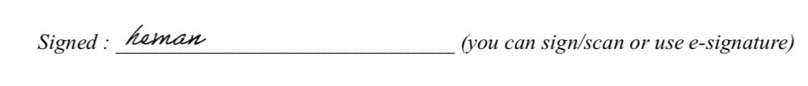

**Team Member 2:**

Print Name: James Stallings Date: 10/02/19

I have contributed by doing following: Many hours coding:  File loader, Normalization, Splitting, re-indexing, Perceptron to include train function and net calculation, early graphing of charts.

**Team Member 3:**

Print Name: Date: 10/02/19

I have contributed by doing following: Along with Jim Stallings, created the perceptron, training algorithm, and data gathering. Along with Heman Baral, produced the perceptron output to help answer questions 2.1, 3 and 2.2. Created the graphs and perceptron output. Set up weight initialization and activation functions.

**Plotting for Dataset A, B & C (All graph has been attached in zip)**

**Dataset A using 75% for training data and 25% for testing**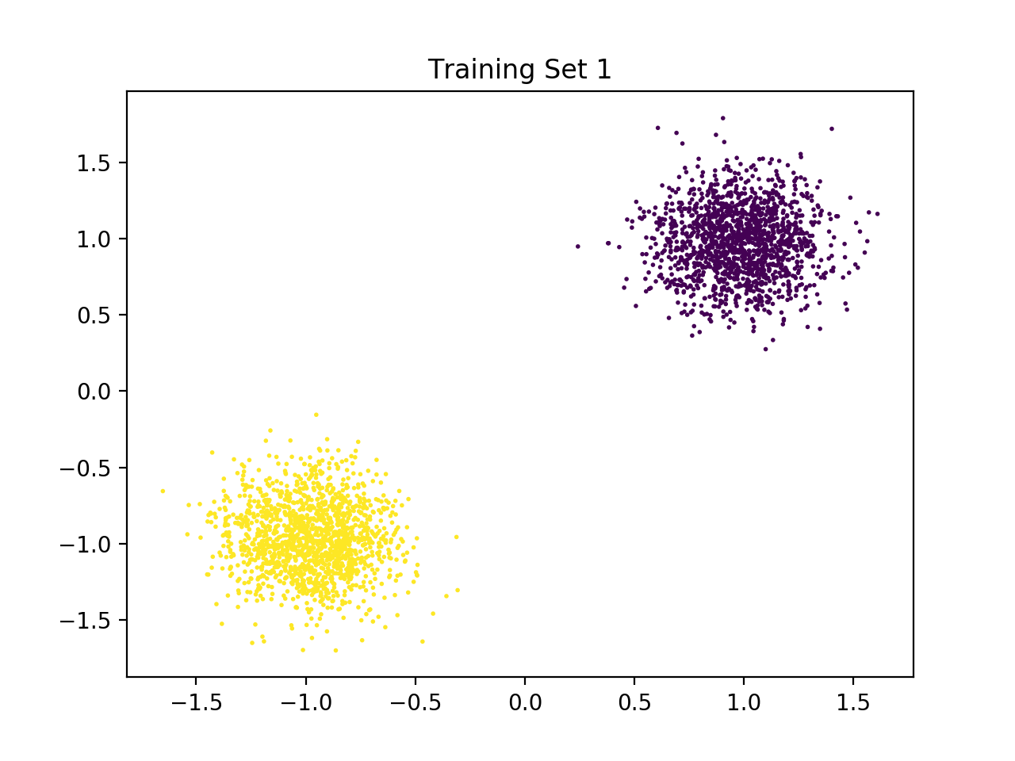

**Dataset B using 75% for training data and 25% for testing**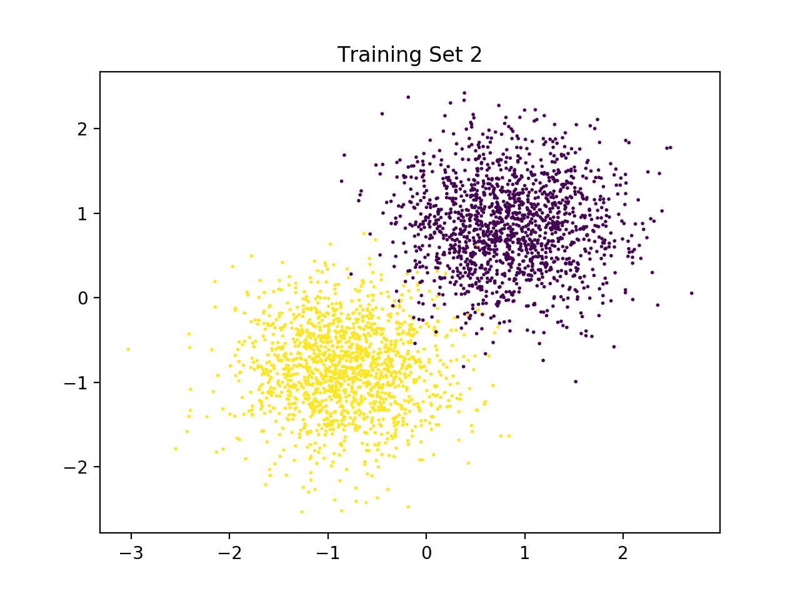

**Dataset C using 75% for training data and 25% for testing**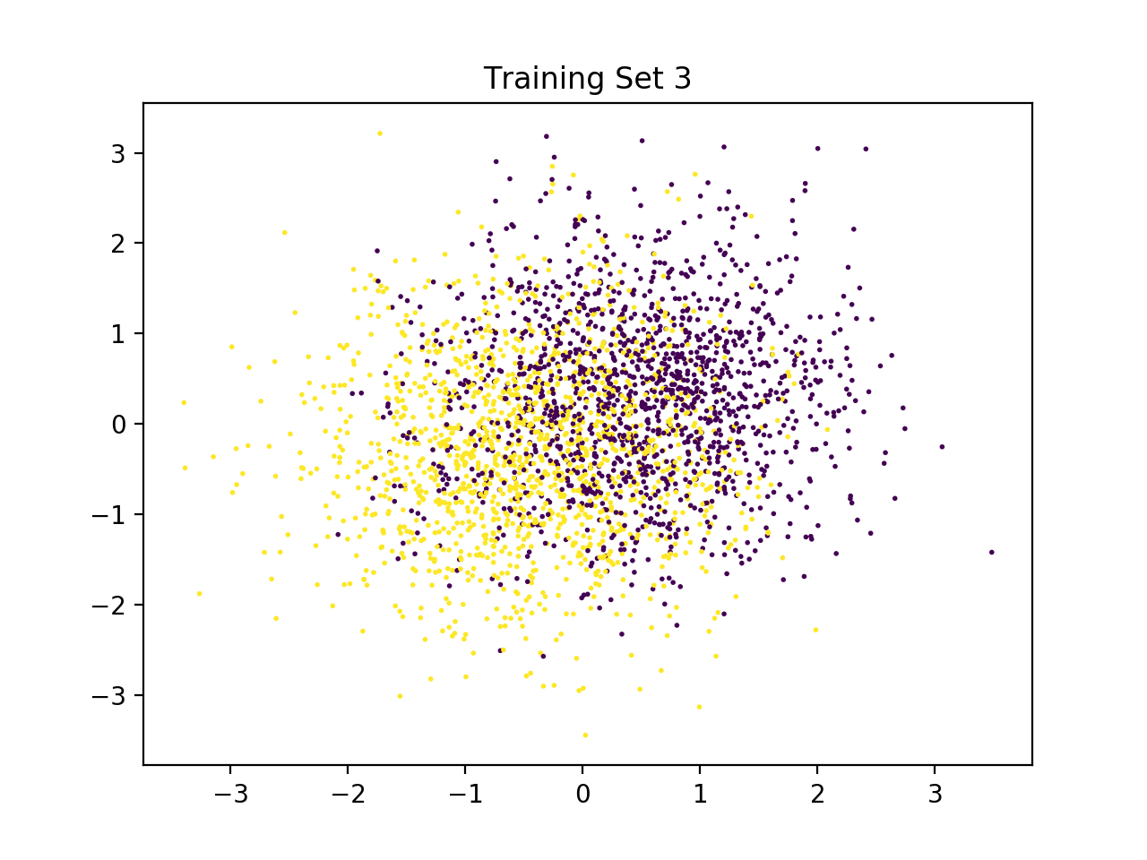

**Dataset A using 25% for training data and 75% for testing**

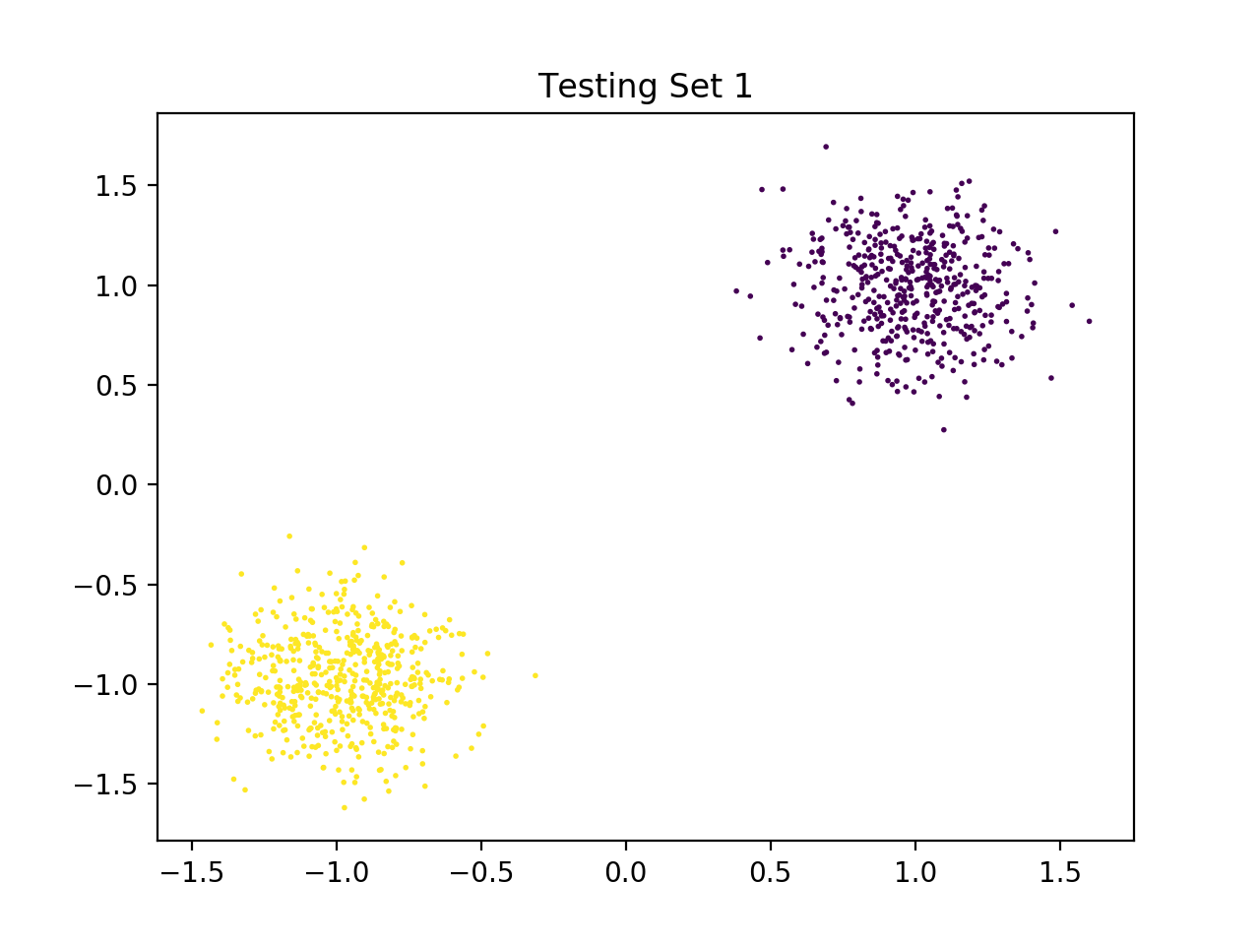

**Dataset B using 25% for training data and 75% for testing**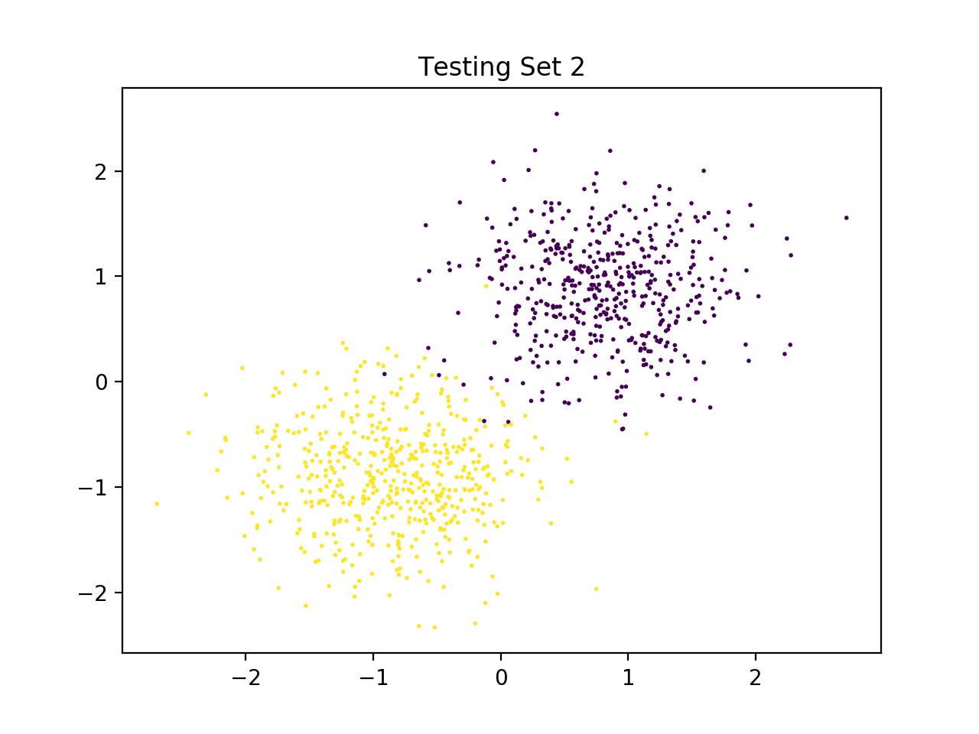

**Dataset C using 25% for training data and 75% for**

**testing**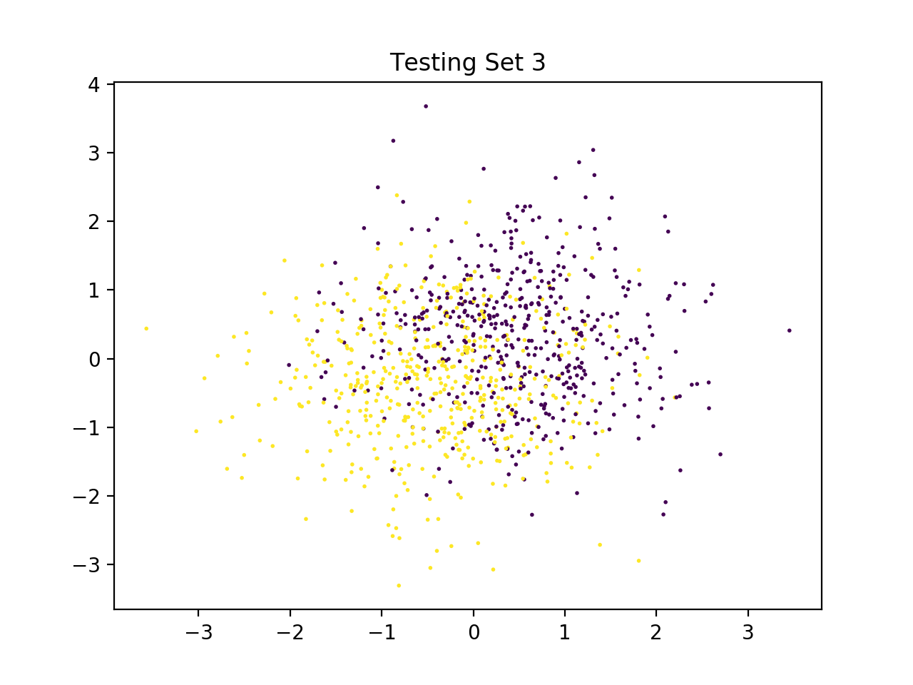

**Scenario A**

| GroupA | Weight | Total Errors | Function | Cycle |
| --- | --- | --- | --- | --- |
| 75 Percent Training | [-6.4356863417566625, -5.337544379087702, -4.7] | 0.0 | Hard Activation | 2 |
| 25 Percent Training | [-5.889482936193268, -3.700936178130269, -4.7] | 0.0 | Hard Activation | 2 |

| GroupB | Weight | Total Errors | Function | Cycle |
| --- | --- | --- | --- | --- |
| 75 Percent Training | [-13.995325167779878, -11.441641279758375, 0.2999999999999998] | 52.0 | Hard Activation | 1 |
| 25 Percent Training | [-9.70904481613379, -12.236581396033865, 0.2999999999999998] | 26.0 | Hard Activation | 1 |

| GroupC | Weight | Total Errors | Function | Cycle |
| --- | --- | --- | --- | --- |
| 75 Percent Training | [-6.437694002461177, -6.32849216024183, 5.300000000000001] | 1043.0 | Hard Activation | 1 |
| 25 Percent Training | [-5.75152403021101, -2.1492040621935002, 5.300000000000001] | 351.0 | Hard Activation | 1 |

Looking at the report, we can see that there is a slight difference in accuracy with the hard activation function having a 25 percent training has better accuracy in some case than 75 percent training data, it depends on each run. If we ran this multiple time, the Total error do fluctuate. In case of lower number iteration, compare to soft activation, the hard activation function will continue to be accurate, but the soft activation function becomes less accurate as the number of iterations decreases.

**Scenario B**

| GroupA | Weight | Total Errors | Function | Cycle |
| --- | --- | --- | --- | --- |
| 75 Percent Training | [-3.5633338833903534, -2.6575055391635423, 1.588372749178137] | 9.661628464472123e-06 | Soft Activation | 6 |
| 25 Percent Training | [-5.722698429232875, -3.8162597529306184, -4.035238682535594] | 7.012646012885335e-06 | Soft Activation | 2 |

| GroupB | Weight | Total Errors | Function | Cycle |
| --- | --- | --- | --- | --- |
| 75 Percent Training | [-10.53139292694997, -8.130367103582076, -0.47825595299528445] | 42.656316655499815 | Soft Activation | 1 |
| 25 Percent Training | [-7.6174837844157475, -6.759570866383983, 2.5164862215477277] | 17.62945850680919 | Soft Activation | 1 |

| GroupC | Weight | Total Errors | Function | Cycle |
| --- | --- | --- | --- | --- |
| 75 Percent Training | [-6.300785523190289, -4.534445121512331, 5.03577373567216] | 1018.0216148997711 | Soft Activation | 1 |
| 25 Percent Training | [-4.763430608029197, 1.0654346482579529, 6.244770059672012] | 345.7239649734139 | Soft Activation | 1 |

According to the result, soft activation results in the lowest error compared to hard activation. Also, soft activation with 25% training data results in the lowest error for the training set and soft activation with 75% training data actually does better for the testing set.

**Program output:**

Compiling Data... Done.

Normalizing data... Done.

Plotting Data Set... Done.

Creating Training Set and Testing Set... Done.

Plotting Training Set and Testing Set... Done.

Training Perceptron using hard activation... Done.

Training Perceptron using soft activation... Done.

********************** RESULTS **********************

Filename: groupA.txt Training Percentage: 75 Function: unipolar hard activation Cycle: 2

Total Error: 0.0 Weights: [-5.313473397416427, -4.264529514877533, 4.6]

Filename: groupA.txt Training Percentage: 25 Function: unipolar hard activation Cycle: 2

Total Error: 0.0 Weights: [-4.3617932486823285, -6.105128181373885, 4.6]

Filename: groupB.txt Training Percentage: 75 Function: unipolar hard activation Cycle: 1

Total Error: 60.0 Weights: [-11.47183260682916, -12.020664635355018, -0.40000000000000036]

Filename: groupB.txt Training Percentage: 25 Function: unipolar hard activation Cycle: 1

Total Error: 31.0 Weights: [-10.311661212224104, -11.904988796116198, 4.6]

Filename: groupC.txt Training Percentage: 75 Function: unipolar hard activation Cycle: 1

Total Error: 1119.0 Weights: [0.9950638658349158, -5.331068316045972, 4.6]

Filename: groupC.txt Training Percentage: 25 Function: unipolar hard activation Cycle: 1

Total Error: 334.0 Weights: [-0.5480251015061606, -3.9306484860720867, -0.40000000000000036]

Filename: groupA.txt Training Percentage: 75 Function: unipolar hyperbolic tangent Cycle: 3

Total Error: 6.048851464279918e-06 Weights: [-3.158995930306627, -2.4964964649433794, 1.65391338613309]

Filename: groupA.txt Training Percentage: 25 Function: unipolar hyperbolic tangent Cycle: 3

Total Error: 5.753715964993524e-06 Weights: [-2.903936456266514, -3.7532421618427425, 2.4551655655593576]

Filename: groupB.txt Training Percentage: 75 Function: unipolar hyperbolic tangent Cycle: 1

Total Error: 54.38372494741496 Weights: [-10.682285980844563, -9.43402388191074, -0.07342651154861579]

Filename: groupB.txt Training Percentage: 25 Function: unipolar hyperbolic tangent Cycle: 1

Total Error: 21.710440267252572 Weights: [-9.225570270976897, -7.636260282019742, 2.9222173405550222]

Filename: groupC.txt Training Percentage: 75 Function: unipolar hyperbolic tangent Cycle: 1

Total Error: 1059.562019275733 Weights: [-2.1166004631715, -7.10687561762864, 5.218956497776685]

Filename: groupC.txt Training Percentage: 25 Function: unipolar hyperbolic tangent Cycle: 1

Total Error: 345.6356964111199 Weights: [-3.6464611913578917, -7.561802706424777, 3.103418498635816]